Material Flow Modelling and Analysis Tool

|  |  |  |
| --- | --- | --- |
|  | | |
| User Manual | |
|  |
| Date | 20 April 2017 |
|  |  |
| Author(s) | TNO |

|  |  |
| --- | --- |
| Copy no. | 1 |
| No. of copies | 1 |
| Number of pages | 1 |
| Number of appendices | 0 |
| Customer | Zhuhai Gaolan Port Authority,  Guangdong Association of Circular Economy and Resources Comprehensive Utilization |
| Project name | CE(Circular Economy) Platform |
| Project number | 060.24321 |

All rights reserved.

No part of this publication may be reproduced and/or published by print, photoprint, microfilm or any other means without the previous written consent of TNO.

In case this report was drafted on instructions, the rights and obligations of contracting parties are subject to either the General Terms and Conditions for commissions to TNO, or the relevant agreement concluded between the contracting parties. Submitting the report for inspection to parties who have a direct interest is permitted.

© 2017 TNO

# Table of Contents

Table of Contents 2

1 Terminology 3

2 Introduction 4

2.1 Tool functions 4

2.1.1 Material flow analysis 5

2.1.2 Edit chemical component 8

2.1.3 Edit petrol chemical process 8

# Terminology

|  |  |
| --- | --- |
| **Name** | **Description** |
| Process block | A block includes the feedstock, products, emission and energy of a petrol chemical process. |
| User | Gaolan port authority |
| Tool | Material flow platform tool |
| Plant | Owned by a company, using at least one main chemical process with optionally some subprocesses. It may consist of multiple processes too. |
| Site | The whole assembly of plants |

# Introduction

This tool is specially developed for Gaolan Port, Zhuhai, China. It is for material flow modeling and analysis.

The tool can help Gaolan port optimize the petrol chemical chain to get max product output and economic value by screening different scenarios for extension of the Gaolan petrochemical complex that adds most value (added value of products) and that does not result in large additional emissions.

The tool includes both the client side and the server side. Figure 1 shows the starting page of the tool on the client side using a modern web-browser which is the user interface. The users only interact with the client side. On the server are all the calculations, data, and a database.

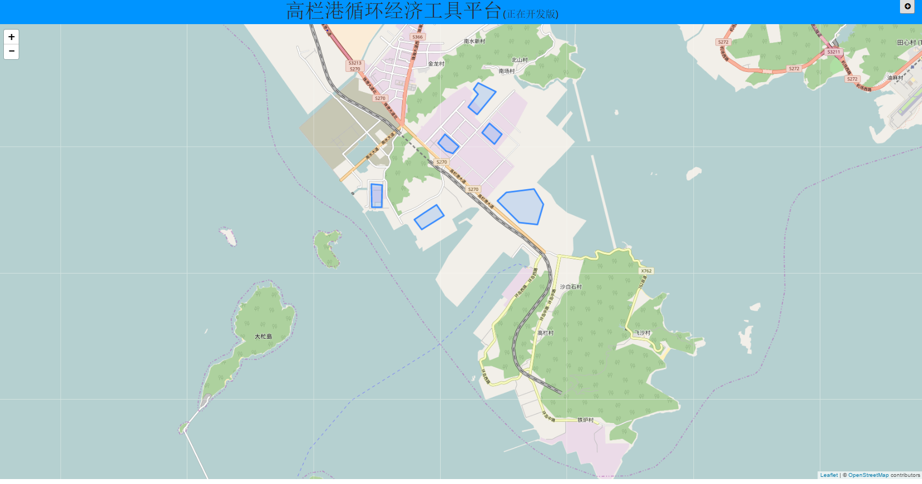

Figure 1. Tool start page

## Tool functions

In this section, the use case described what a user can do and what a user can get from the tool.

### Material flow analysis

* (option for Gaolan) see the whole site description quantitatively within an site, so that you can show to (potential) plants.

**Data required: whole site related statistic data**

* (Option for Gaolan) see the petrol chemical processes connected through main feedstock / main product mass streams in a chart, in order to have an overview of the processes and plants using those processes. See Figure 2. However, it should be mentioned that the connections among the processes happen in the backend or on the server side.

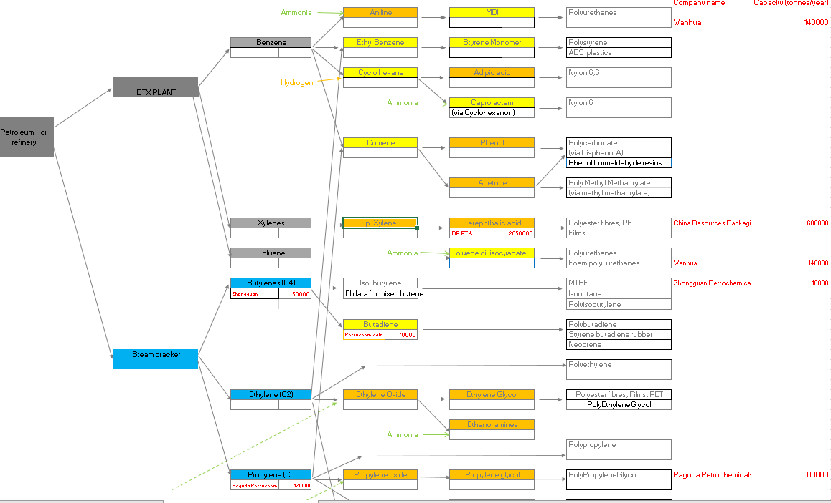

Figure 2. Example of Petrol-chemical process chain

* add defined process(es) to existed plants. After added, the change for the individual plant is displayed and the changes in the available data in Gaolan port site. The change means the emission change, material consumption, and production, economic margin change.

The difference for the individual plant change and site change is that for the site change, the upstream processes of the selected process will be calculated.

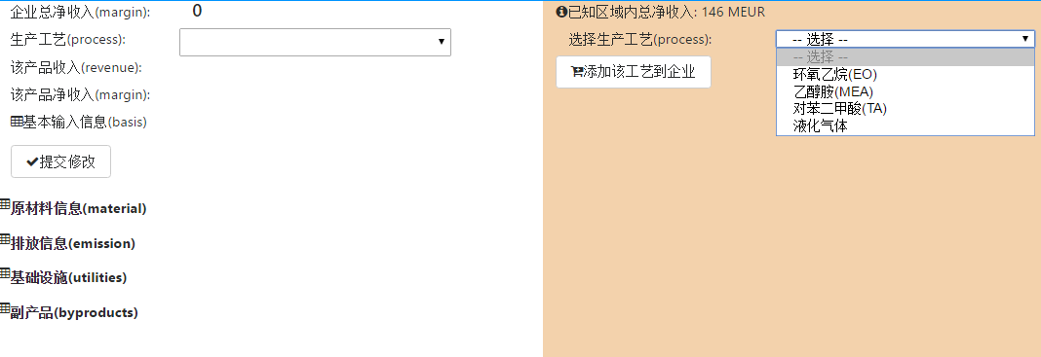

Figure 3. Add process to plant

* create new plants by drawing a polygon on the map, then add process(es) to them, in order to simulate the situation after a new plant is working in Gaolan Site. After added, the potential whole material flow change in the site will be displayed.
* (Option for Gaolan) see the energy change/recycling, so that to identify the energy-related issue
* Click a plant on the map, so that all the information about products, by-products, raw material, the emission is displayed.

**Data required:** spatial location of the plant, actual product name, and capacity *(except the data required,* ***all information is calculated by TNO, which is used as benchmark****)*

Figure 4 shows the Zhuhai BP plant producing PTA. 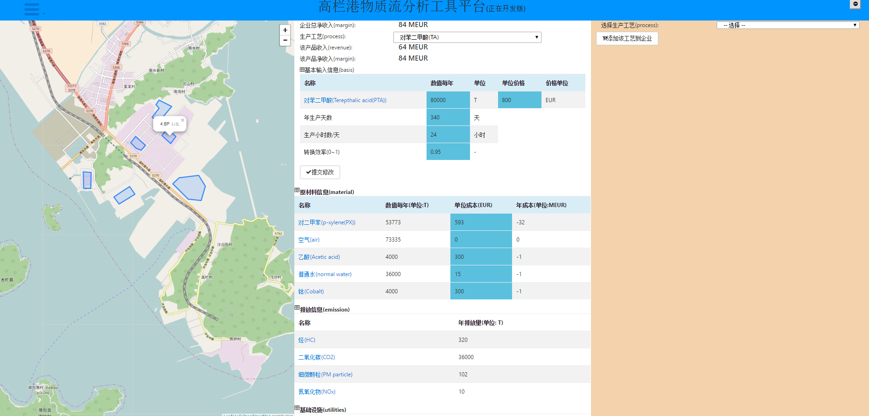

Figure 4. Zhuhai BP plant produces PTA, In order to produce 80000 tons of PTA, it needs 53773 tons of PX and others. And it produces 36000 tons of CO2.

* Change the capacity of production or local chemical price, so that the added value will be visible. Also increased emissions and energy use corresponding with this change will be made visible

Figure 5. Change the capacity

After submit, the material consumption will be changed. (see Figure 6, and compare with Figure 5)

Figure 6. Updated information on changing the capacity

* Click on a product or a raw material, so that plants making use of the product or supplying the raw material will be highlighted on the map. It shows a (potential) connection between plants

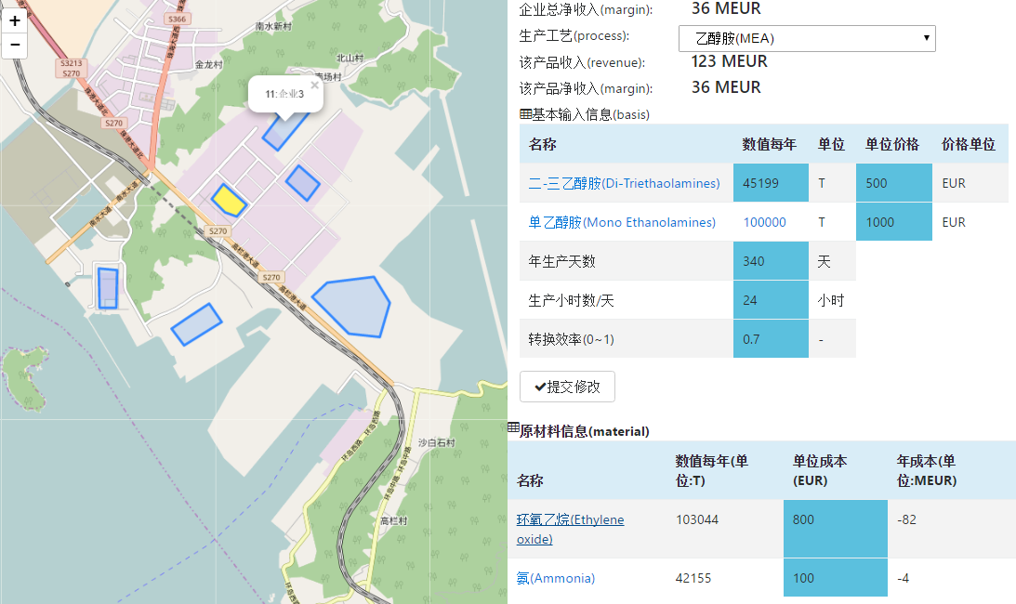

plant supply EO is highlighted

Click here

Figure 7. In this picture, “企业3“ produces MEA which needs EO and Ammonia. After click on “环氧乙烷(Ethylene oxide)”, a polygon on the map is highlighted with yellow color, indicating that this plant is producing EO, so that it can supply EO to “企业3“

### Edit chemical component

The user is able to edit the existed chemical components or insert new components into the database. This provides the platform the capability to include new components in the future. This is also necessary in order to add new chemical processes.

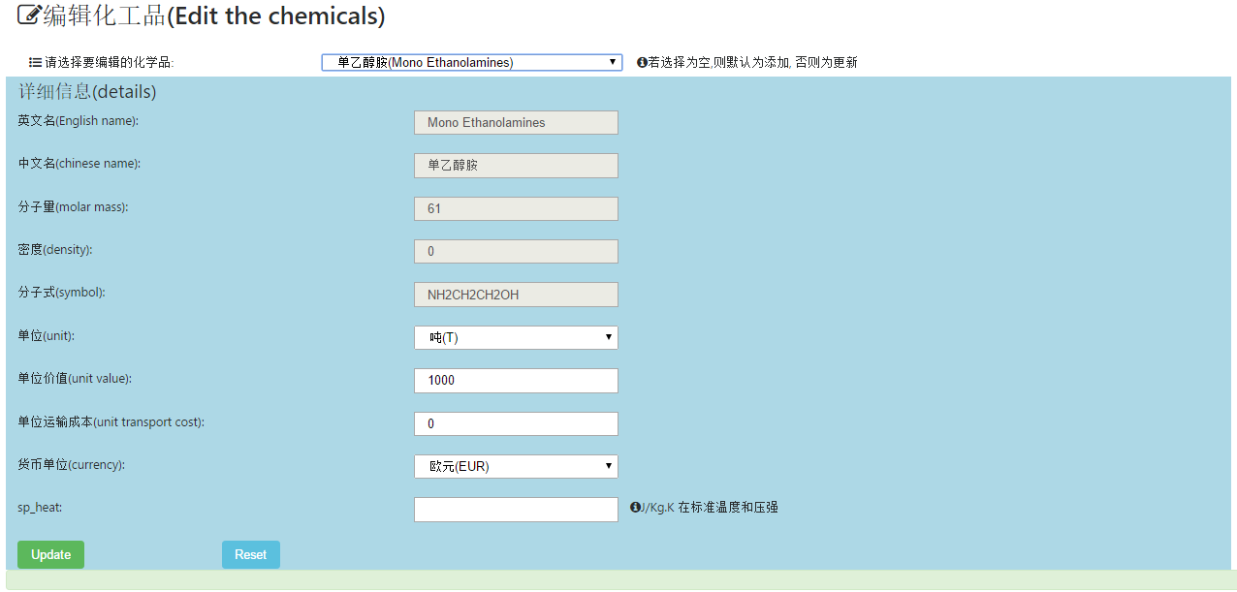

Figure 8. Edit chemical component

### Edit petrol chemical process

TNO will create a few process blocks. Since the petrol chemical chain contains a lot of processes, it is necessary to have a function to let the user/TNO add new chemical process or edit existed chemical process. This requires the introduction of locally collected data on mass flows, reaction efficiency, energy use and emission data etc.

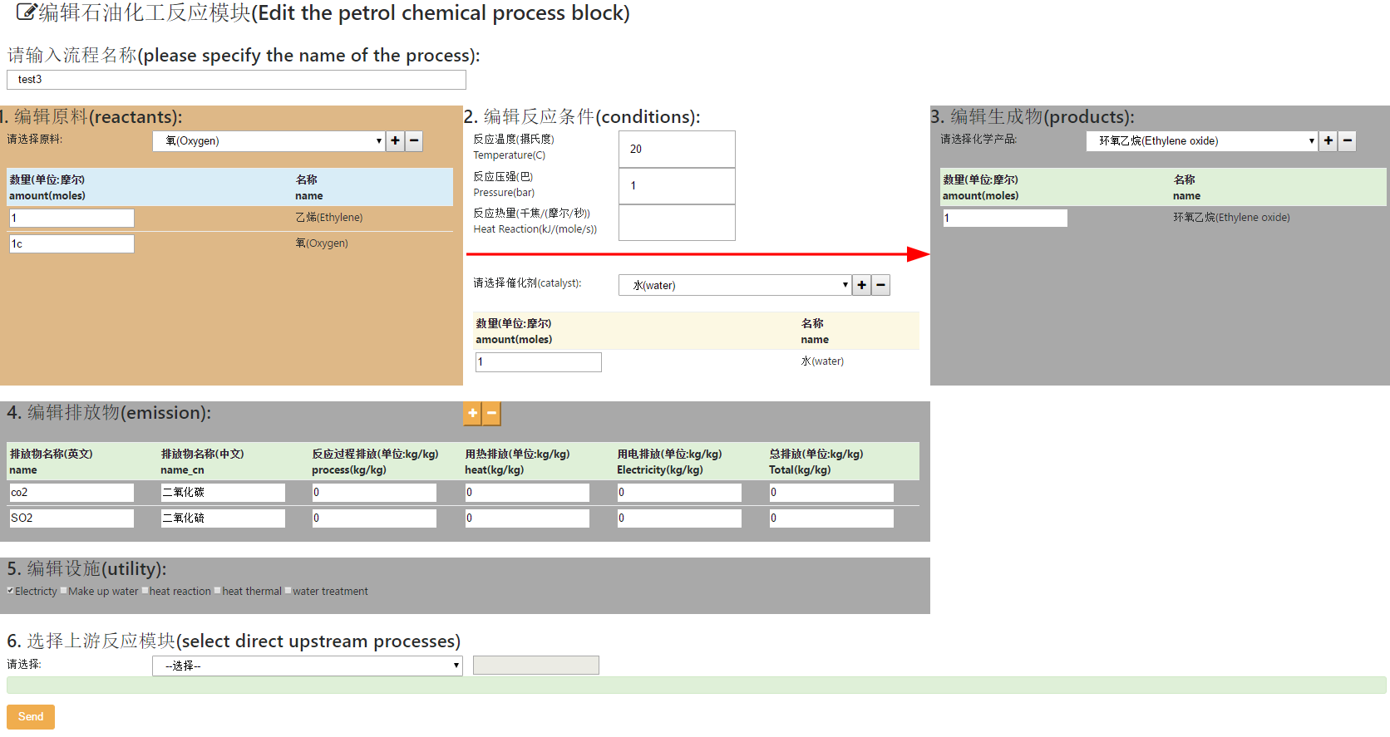

Figure 9. Add new chemical process